Project Design Phase-II
Technology Stack (Architecture & Stack)
Date | 8 March 2026
Team ID
Project Name | Avi-Luxe E-commerce Application
Maximum Marks | 4 Marks

Technical Architecture
The Avi-Luxe application follows a classic 3-Tier Architecture: a React 19 Presentation Tier, a Node.js/Express 5 Business Logic Tier, and a MongoDB Atlas Data Tier. The architecture is stateless and RESTful — the frontend communicates exclusively via Axios HTTP calls carrying a JWT Bearer token, and the backend processes each request independently without server-side session state.

Architecture guidelines applied:
• All processes (pages, controllers, models) are shown as distinct Technology Blocks with clear boundaries
• Infrastructure demarcation: Client (browser/CDN), Server (Railway/Render), Database (MongoDB Atlas), External Services
• External interfaces shown: Payment Gateway (Razorpay/Stripe), CDN (Cloudinary), Email (Nodemailer), OAuth (Google/Facebook)
• Data storage components: MongoDB collections for users, products, carts, orders, admins
• No ML model used in current implementation — GSAP/Three.js provide visual intelligence

Architecture Diagram — Avi-Luxe (3-Tier)
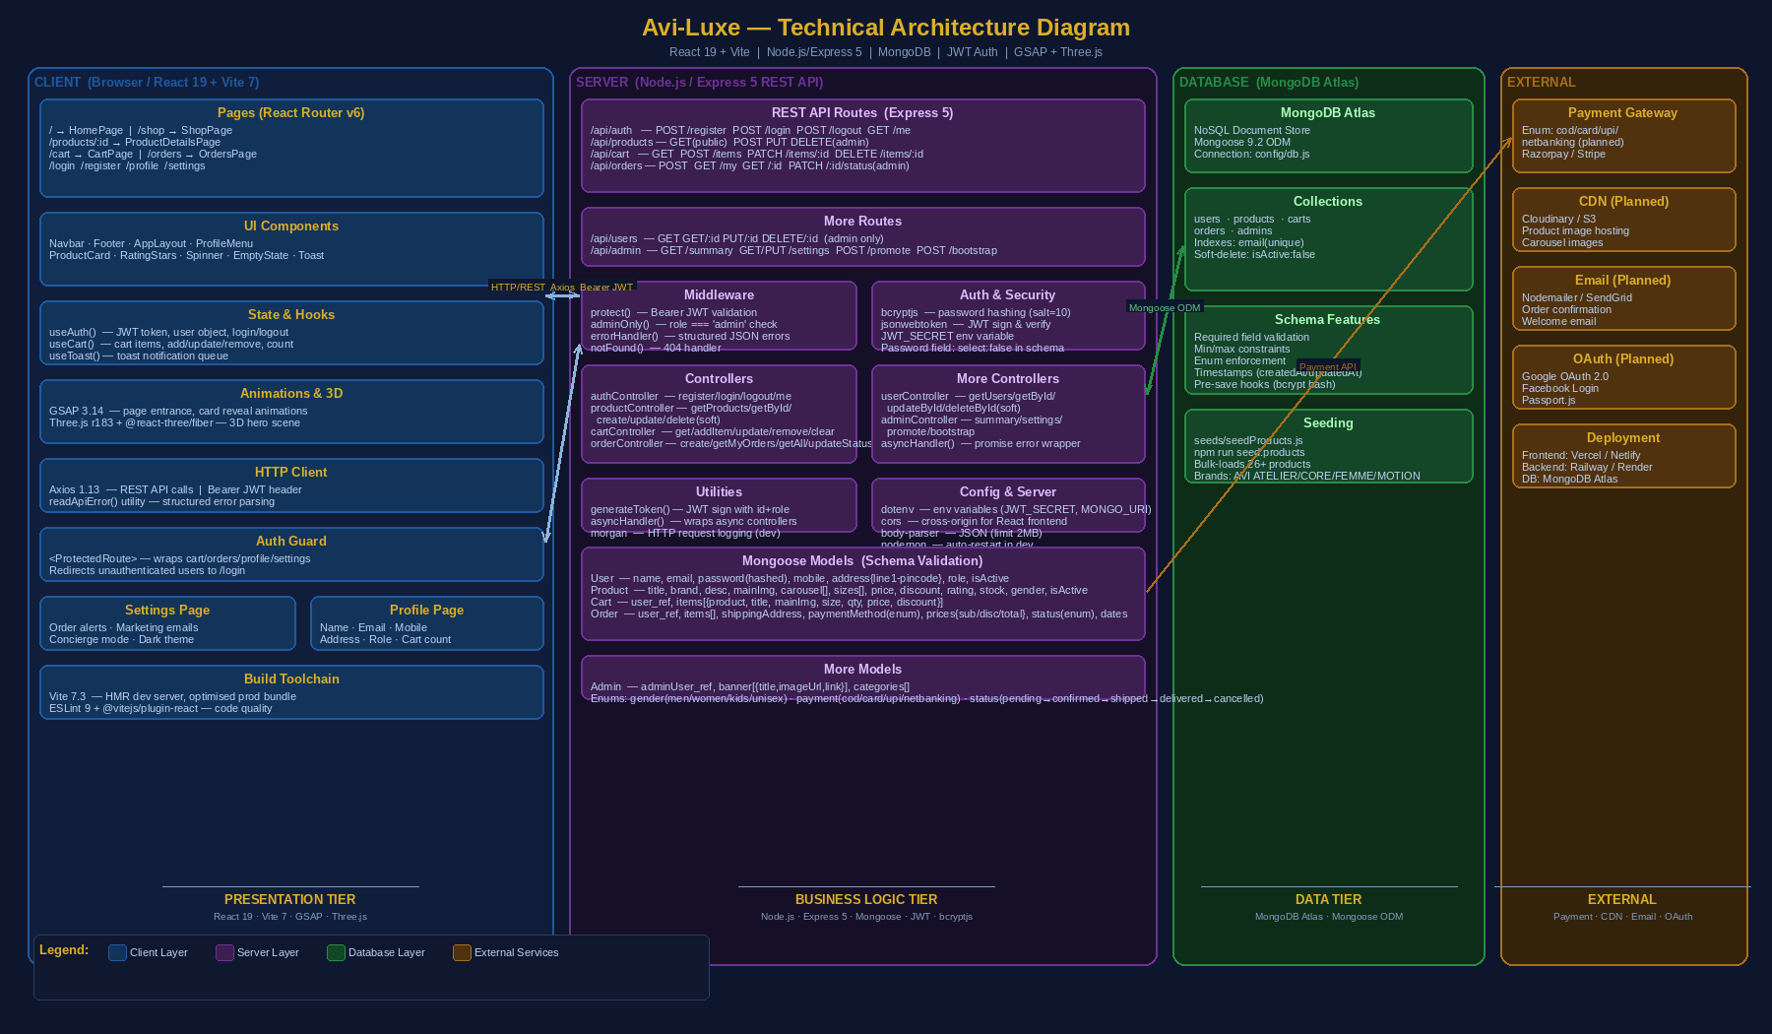

Architectural Flow
1. Browser (Client Tier): The user accesses the React 19 SPA via browser. Vite serves a production-optimised bundle. React Router v6 handles client-side navigation across 9 pages. Custom hooks manage state: useAuth() stores the JWT and user object in memory, useCart() syncs cart state with the backend, useToast() manages notification display. All HTTP calls go through Axios with a Bearer JWT Authorization header.
2. API Gateway (Business Logic Tier): The Express 5 REST server exposes 6 route groups (/api/auth, /api/products, /api/cart, /api/orders, /api/users, /api/admin). The protect() middleware validates the JWT on every non-public route. adminOnly() provides a second RBAC gate for admin-only endpoints. All controller functions are wrapped with asyncHandler() to forward errors to the global errorHandler middleware.
3. Database (Data Tier): Mongoose 9.2 ODM manages 5 MongoDB collections. Schema-level validation (required, minlength, enum, min/max) is enforced before any write. The User schema's pre-save hook hashes passwords with bcryptjs. Soft-delete is used throughout (isActive:false) to preserve order and cart history.

Table 1 — Components & Technologies
The following table describes each component in the Avi-Luxe system, its purpose, and the specific technologies used. All entries are based on the actual implemented codebase (package.json, routes, controllers, models, and client pages).

S.No | Component | Description | Technology
1 | User Interface (Web App) | React 19 SPA delivered via Vite 7 dev server. Users interact through a dark luxury-themed browser application with GSAP animations and Three.js 3D hero visuals. Fully responsive layout with React Router v6 navigation. | React 19 · Vite 7.3 · React Router v6 · CSS Modules · GSAP 3.14 · Three.js r183 · @react-three/fiber · @react-three/drei
2 | Application Logic — Frontend | All client-side business logic handled via custom React hooks: useAuth() manages JWT token and user session; useCart() manages persistent cart state (add/update/remove/count); useToast() manages notification queue. ProtectedRoute wraps authenticated pages. | React 19 Hooks (useState, useEffect, useMemo, useRef, useLayoutEffect) · Custom hooks: useAuth, useCart, useToast · React Context API
3 | Application Logic — Backend (Auth) | JWT-based stateless authentication. Registration validates uniqueness (HTTP 409 on duplicate), hashes password with bcryptjs (salt=10), issues JWT token. Login validates credentials, checks isActive flag, returns JWT. protect() middleware verifies Bearer token on every protected route. | Node.js 20 · Express 5 · jsonwebtoken 9 · bcryptjs 3 · JWT_SECRET (env var) · authMiddleware.js (protect + adminOnly)
4 | Application Logic — Backend (Business) | RESTful controllers handle: Product CRUD with server-side filtering (category, gender, price range, regex search); Cart management (add/increment/update/remove/clear); Order creation with server-side price calculation (subtotal, per-item discount, total); Admin summary aggregation via MongoDB pipeline. | Express 5 Controllers: authController · productController · cartController · orderController · userController · adminController · asyncHandler utility
5 | Database | MongoDB NoSQL document store accessed via Mongoose 9.2 ODM. Six collections: users (email unique index), products (isActive soft-delete), carts (per-user), orders (status enum pipeline), admins (settings doc). Schema-level validation: required fields, min/max, enums, pre-save bcrypt hook. | MongoDB Atlas · Mongoose 9.2 · Schema types: String, Number, Boolean, Date, ObjectId, Array · Pre-save middleware · .timestamps()
6 | Cloud Database | MongoDB Atlas cloud-managed cluster. Provides managed replication, automated backups, and connection string via MONGO_URI environment variable. Accessed from Node.js backend using Mongoose connection defined in config/db.js. | MongoDB Atlas (M0 Free Tier → Production cluster) · MONGO_URI (dotenv) · config/db.js connection manager
7 | File / Media Storage | Product images and carousel arrays are stored as URL strings in the Product document (mainImg and carousel[] fields). No server-side file upload implemented. External CDN (Cloudinary or AWS S3) is planned for production image hosting and delivery. | URL string storage in MongoDB (current) · Cloudinary / AWS S3 (planned) · product.mainImg + product.carousel[] fields
8 | External API — Payment Gateway | Order model supports payment methods: COD (Cash on Delivery), Card, UPI, and Net Banking via enum field. Client UI currently exposes COD only. Full payment gateway integration (Razorpay or Stripe) is planned to handle card/UPI/netbanking flows. | Payment enum: cod | card | upi | netbanking (Order model) · Razorpay / Stripe (planned integration) · Cart checkout UI
9 | External API — Email Service | No email service is currently implemented in the codebase. Registration does not send confirmation emails. Order placement does not send receipts. Nodemailer with SendGrid or Gmail SMTP is planned for: welcome emails, order confirmations, and delivery status updates. | Nodemailer (planned) · SendGrid / Gmail SMTP (planned) · Triggers: register, order confirmed, status changed
10 | External API — OAuth | Authentication is currently email+password only. Google OAuth 2.0 and Facebook Login are planned for future sprints. Implementation will require Passport.js with passport-google-oauth20 and passport-facebook strategies on the Express server. | Google OAuth 2.0 (planned) · Facebook Login (planned) · Passport.js + passport-google-oauth20 (planned)
11 | Infrastructure — Server | Development: Node.js server run with nodemon (auto-restart). Vite dev server with HMR for frontend. Production deployment planned on Railway or Render (backend) and Vercel or Netlify (frontend). Environment configuration managed via dotenv for MONGO_URI, JWT_SECRET, PORT, NODE_ENV, ADMIN_SETUP_KEY. | Development: nodemon 3.1 + Vite 7 HMR  Production (planned): Railway / Render (backend) · Vercel / Netlify (frontend)  Config: dotenv 17 · NODE_ENV · PORT

Table 2 — Application Characteristics
The following table describes the non-functional quality characteristics of the Avi-Luxe application across five dimensions: open-source frameworks, security, scalability, availability, and performance.

S.No | Characteristic | Description | Technology
1 | Open-Source Frameworks | All dependencies are open-source with active communities and MIT/Apache licences. Frontend: React 19 (Meta), Vite 7 (Evan You), React Router v6 (Remix), Axios (MIT), GSAP (Greensock free tier), Three.js (MIT), @react-three/fiber (Poimandres). Backend: Express 5 (MIT), Mongoose 9 (MIT), jsonwebtoken (MIT), bcryptjs (MIT), cors (MIT), morgan (MIT), body-parser (MIT), dotenv (BSD-2), nodemon (MIT). | React 19 · Vite 7 · Express 5 · Mongoose 9  GSAP 3 · Three.js r183  Axios · jsonwebtoken  bcryptjs · cors · morgan  nodemon · dotenv
2 | Security Implementations | 1. Password hashing: bcryptjs with salt rounds=10 — passwords never stored in plain text.  2. JWT authentication: RS256/HS256 signed tokens verified on every protected API request via protect() middleware.  3. Role-based access control: adminOnly() middleware rejects non-admin requests with HTTP 403.  4. Password field protection: Mongoose select:false ensures password hash never returned in API responses.  5. Inactive account blocking: isActive:false flag checked at login — deactivated accounts receive HTTP 403.  6. Admin bootstrap key: ADMIN_SETUP_KEY env variable protects first-admin creation endpoint.  7. Input validation: Mongoose schema-level required, minlength, enum constraints prevent malformed data.  8. CORS: configured to allow only the React frontend origin in production. | bcryptjs (salt=10)  jsonwebtoken  JWT Bearer middleware  adminOnly() RBAC  select:false (password)  isActive account guard  ADMIN_SETUP_KEY env  Mongoose validation  CORS policy
3 | Scalable Architecture | 3-Tier Architecture:  • Presentation Tier: React SPA — stateless, deployable to any CDN (Vercel/Netlify). Components modularised into pages/, components/common/, components/layout/, hooks/, services/.  • Business Logic Tier: Stateless Node.js/Express REST API — each request is independently processed. Controllers, routes, middleware and models are fully decoupled. New features (e.g. reviews, wishlist) can be added as new route+controller+model triples without refactoring existing code.  • Data Tier: MongoDB document model supports flexible schema evolution. Collections scale independently. Atlas provides horizontal scaling via sharding.  Role-based system (user/admin) is extensible to additional roles (vendor, support, logistics). | 3-Tier Architecture  Stateless REST API  MongoDB horizontal scale  Atlas sharding support  Modular client structure  Decoupled controllers  Role extensibility  (user → admin → vendor)
4 | Availability | Current setup:  • Health check endpoint: GET /api/health returns {status:'ok'} — enables uptime monitors (UptimeRobot, Render health checks) to detect downtime.  • Nodemon auto-restart in development minimises dev downtime.  • Express error middleware (errorHandler, notFound) ensures unhandled errors return structured JSON rather than crashing the server.  Planned for production:  • Frontend deployed to Vercel/Netlify with global edge CDN — 99.99% uptime SLA and automatic failover.  • Backend deployed to Railway/Render with auto-restart on crash and rolling deployments.  • MongoDB Atlas provides multi-region replication and automated failover (M10+ cluster). | GET /api/health check  Express error boundary  nodemon (dev restart)  Vercel/Netlify CDN (planned)  Railway auto-restart (planned)  MongoDB Atlas replication  Multi-region failover (planned)
5 | Performance | Frontend:  • Vite 7 build — code splitting, tree-shaking, and minification produce optimised production bundles.  • 350ms debounce on ShopPage search input — reduces API calls per keystroke by ~70%.  • GSAP uses GPU-accelerated CSS transforms (translate3d, will-change) for smooth 60fps animations.  • React 19 concurrent features — useMemo for cart totals and product count prevents unnecessary re-renders.  Backend:  • Server-side product filtering with Mongoose query operators — only matching documents transferred to client.  • Body-parser limit 2MB prevents oversized payload abuse.  • MongoDB createdAt index on all collections enables efficient sorted queries.  • asyncHandler utility eliminates try/catch boilerplate — consistent low-overhead error handling. | Vite 7 code splitting  350ms search debounce  GSAP GPU transforms  React 19 useMemo  Server-side filtering  MongoDB sort indexes  body-parser 2MB limit  asyncHandler wrapper

References
• C4 Model — Architecture Diagramming: https://c4model.com/
• IBM Architecture Patterns: https://www.ibm.com/cloud/architecture
• AWS Architecture Centre: https://aws.amazon.com/architecture
• React 19 Documentation: https://react.dev
• Express 5 Documentation: https://expressjs.com
• Mongoose 9 Documentation: https://mongoosejs.com
• Vite 7 Documentation: https://vitejs.dev
• GSAP Documentation: https://gsap.com/docs
• Three.js Documentation: https://threejs.org/docs
• MongoDB Atlas: https://www.mongodb.com/atlas
• JWT Standard (RFC 7519): https://datatracker.ietf.org/doc/html/rfc7519
• bcryptjs: https://github.com/dcodeIO/bcrypt.js
• Project Repository: https://github.com/AVK103/Avi-Luxe__E-commerce-Application

